GWJ Digital Grain Hardness Meter User Manual

- Introduction
GWJ-1 Digital Grain Hardness Meter is a professional instrument for testing the hardness of grain (wheat, rice and so on). It adopts latest technology and has high accuracy and resolution. It’s easy to operate and widely used in agriculture development and education.
- Functional features
- Digital display, easy to read, high precision
- Light weight, small size, easy to carry
- Unit display: Kg, N
- 3.7V lithium battery with short circuit, leakage and overload protection:
- Measurement methods: Real-time, Peak value.
- Shape structure
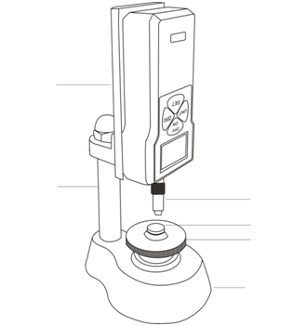
Pressure head
Objective table
Hand wheel
Adapter plate

Stand

Pedestal
LCD
- Technical parameter
Model specifications | GWJ-I
Maximum load value | 20Kg
 | 196N
Load scale value | 0.01kg
 | 0.1N
Sensor structure | Built-in
Accuracy | ±2％
Power | 3.7V lithium battery
Charging Time | 4 - 6 hours
Battery continuous use of time | About 15 hours
Battery Life | ≥300times
Charger | Input: AC 220V 50HZ  Output: DC 5V 1000mA
Operating temperature | 5℃～35℃
Transport temperature | -10℃～60℃
Relative humidity | 15％～80％RH
working environment | No Vibration source and Corrosive medium around

- Screen display
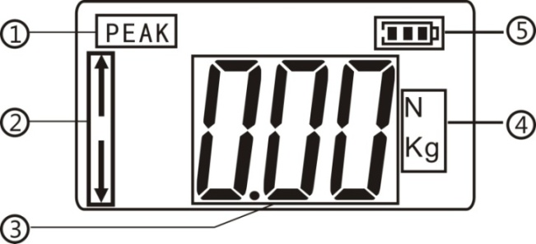
①Peak mode: After startup, enter the measurement interface, press "SET" button to enter the "peak mode". It is to record the maximum value measured in a time period.
②Force situation: while the meter is in static state, the upper arrow means pull, and the arrow means thrust.
③ Hardness value
④Two units: Kg, N; Press "UNIT" to convert.
⑤Power display

- Buttons introduction
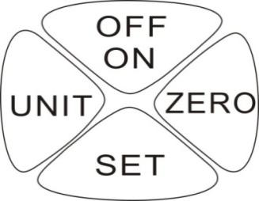
OFF/ON: Switch on or switch off.
ZERO: Press this button to make hardness value return to zero.
SET ("Mode switch" button): In the measurement interface, press this button to enter the peak measurement mode. And keep press it for 5-6 seconds to enter the setting interface.
UNIT: unit-convert button. Keep press the "UNIT" button for 5 to 6 seconds to convert.
- Boot display
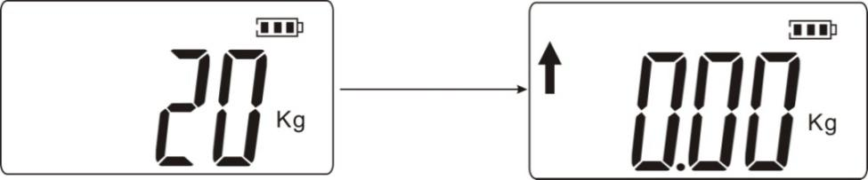
- Function Introduction
As shown in the figure below:
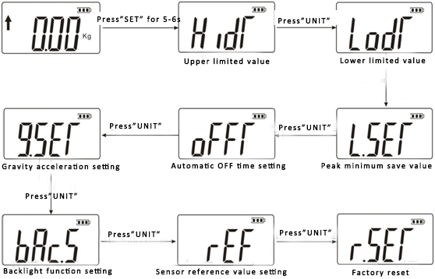
(HIDT) Upper limited value setting: The default value as 100% of full range. The meter will alarm when the values go beyond upper limited; press “UNIT” and “ZERO” BUT” button to re-set the upper limited value; and press “SET” to save your setting. The specific operation is as below:
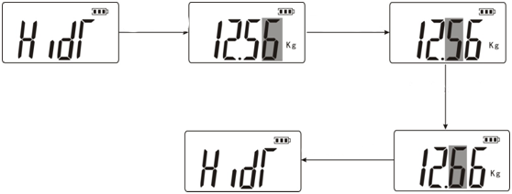
Press "set" to save
Press “unit”
Press "set" s
Press "zero"
(LODT)Lower limited value setting: default value as 0. The meter will alarm when the values go beyond upper limited.
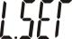(L.SET)Peak minimum save value: on the peak mode, when the current value is less than the peak minimum save value, current value will not be saved.
(OFFT)Automatic OFF time setting: by pressing the "UNIT" button and the "ZERO" button, 1-9999minutes auto off time can be set. Or set “00” to make the meter never auto off, and then press “SET” to save your setting, and return to main interface. The default auto off time is set as 10m.
(G.SET) Gravity acceleration setting: the value is able to set according to current position. The default value is 9.800.
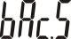(bAC.S)Backlight function setting: Under this setup project, press "UNIT" button,” (YES)” for opening backlight, “(NO)” for closing backlight, then press the "SET" button to save and return to the Settings project interface.
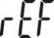 (rEF) Sensor reference value setting: It is unnecessary to do this setting.
Factory reset function: Under this setup project, Press the "SET" button to restore the factory default,

- Method of use
- Switch on the meter and enter the measurement interface. Select real-time or peak measurement mode as needed.
- For small size grains, fix the grain with a tweezer (preferably vertical), and then rotate the hand wheel to move the mandril upward slowly with pressure, at this point, the meter starts display the value of the stress load, and reach to the maximum load value the moment when the grains be crushed.
- If retest needed, clear residue on the meter, and then press the "ZERO" button to zero the value. Next steps as 1.
- When test finished, clean the meter, switch off it, and then place all parts in to case.

- Safety precautions
- Precautions:
- Before your first time, please check the meter and see whether the electricity enough or not. If no, please charge it for 4-6 hours.
- Before your operation, read our manual carefully, in case of any damages would cause because of your incorrect operation.
- Warning:
- Do not use pressure head which is damaged or badly bent.
- If the max range is exceeding, do not use the meter, otherwise the sensor inside will damage, even cause accident.
- When the test value exceeds 100% of the full range, the meter will alarm with keep beeping, please release the load or reduce load quickly; when it exceeds 120% of the full range, the instrument maybe damag.
- When the instrument accidentally crashes, use a hard little round rod to press "reset" button of the instrument at right side to reset.
- Security matters:
- Please use the supporting charger to charge; otherwise it will cause a circuit fault, even a fire.
- The charger should be used within its rated voltage; otherwise it might cause an electric shock or fire.
- Don’t pull out or plug the power with a wet hand, otherwise it may cause shock.
- Please do not operate the machine in the following environments: Humid environment Dusty environment ,Use of oil or chemicals, around source area
- Please use and store the meter within the specified temperature and humidity range, otherwise the instrument may breakdown.
- Do not disassemble or repair the machine by yourselves, because it may cause permanent failure of the instrument.
- Other safety production needs to be noted.
- Confirm the project before repair:
Power | Symptoms | phenomenon | Set
 | Press "ON/OFF" without any display | Battery run out | Recharge
Test value | The test value is not accurate | oversize error | Return to factory for calibrating
Else | Accidental crash | Press any keys but no reaction | Press "reset" with a needle

- Packing list

Items. | QTY
Grain hardness Meter | 1
Charger (5V, small head) | 1
Use manual | 1
Warranty card | 1
Desiccant | 1
Hexagonal nut(M6) | 1
Height adjustment table A/B | 1 each

